REMC 2 South
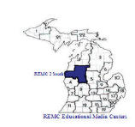

Presents

21 Things for the 21st Century Educator
Technology Every Educator Should Know
http://21things4teachers.net

Instructor: Sharrie Parke

A collaborative project created by:
Carolyn McCarthy, Instructional Technology Consultant
Dr. Jennifer Parker-Moore, Interactive Learning Consultant
Jan Harding, Interactive Learning Consultant
Melissa White, Instructional Technology & Media Consultant

Course | Dates
Cohort 8 | REMC 2 South  January – April 2013

All participants will be following the Graduate Course Syllabus, which includes those seeking professional development hours, SCECHs or graduate credits.

EDU 508 Course Title: 21 Things Every 21st Century Educator Should Know (21things4teachers) (3 or 4 Credit Hours)

Course Description –
Graduate Credits Available through Central Michigan University, SBCEUs may be available
The purpose of the 21things for 21st Century Educator (21Things4Teachers) course is to provide ”Just in Time” training through an online interface for K-12 educators based on the National Educational Technology Standards for Teachers (NETS-T) and Administrators (NETS-A). These standards are the basic technology skills every educator should possess. Educators will have the opportunity to develop their own skills, obtain SBCEUs or Graduate Credit, and discover student skills needed to meet Michigan Educational Technology Standards (METS) and Michigan Merit Curriculum Online Experience requirements.

Instructors:
The 21things for the 21st Century Educator web site was created through a collaborative effort between the instructional technologists at Clinton RESA, Macomb ISD, Ingham ISD and Shiawassee RESD. The co-creators, or Project Partners, are as follows:

- Carolyn McCarthy, Clinton RESA/Shiawassee RESD
- Jennifer Parker-Moore, Ed. D., Macomb ISD
- Melissa White, Ingham ISD
- Janice Harding, Macomb ISD

Local Instructors: On file with the University, working as an approved Agency/Agency Coordinator

- Sharrie Parke, Instructional Technology Consultant

Course Goals
- To tie the use of instructional technology to research based instructional strategies that improve the effectiveness of classroom instruction.
- Michigan Technology Planning and Reporting: Use of the 21things project supports the Michigan Technology plan and MEGS reporting required of districts. The course allows for assessment of professional standards for Michigan teachers' in Personnel Skilled In Technology as reported on MEGS using the NETS-T and NETS-A rubrics. Educators participate virtually in an online technology course based on curriculum, assessment, and instructional models aligned to the NETS and METS.
- Collaboration to Meet Educator Needs: The 21things for the 21st Century Educator site is a collaborative project designed under a Creative Commons license to fill the needs of educators for web 2.0 technology applications and training. This project helps districts bridge the widening gap between students and teachers technology skills. It also provides cost-effective ways to provide professional development, the flexibility of any-time (just-in-time) training, and FREE web tools aligned to state and national standards.
- To assist teachers in meeting the National Educational Technology Standards for Teachers
- To assist school districts in determining “Personnel Skilled in Technology” as required for state reporting
- To expose teachers to an online course as required of Michigan high school students by the Michigan Merit Curriculum online requirement
- To develop teacher proficiency in the integration of Michigan Educational Technology Standards for Students into classroom instruction
- To allow for assessment, critical evaluation, and self-reflection of technology skills as determined by state and national standards
- To provide teachers with differentiated strategies in the area of instructional technology
- To assist teachers in building skill levels to bridge the digital divide

Required Text/Readings:
Participants are expected to complete the readings and activities associated with the 21 online lessons to learn basic technology skills using a variety of web tools in a blended learning environment. Each lesson, or “thing”, includes a “how to” video, hands-on activities, ties to the National Educational Technology Standards (NETS-T) standards, and an overview of how this tool can be used in the classroom. Participants demonstrate proficiency in each of the 21things by creating an end-product, or a Digital Portfolio. Additional readings may be added to the enrich content.
National Educational Technology Standards for Teachers: http://www.iste.org/AM/Template.cfm?Section=NETS
Effective teaching and learning strategies, based on the work by McREL/Marzano http://web.gc.k12.va.us/vste/2008/

Participants will be expected to complete all of the readings associated with each “Thing”, found at the following sites:
http://www.21things4teachers.net
On each page of the web site, there are required readings for each of the 21 things elements.

- Introduction to the Course
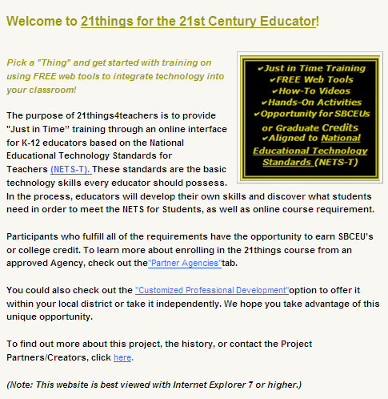
- About Basics
- Face of the Classroom (Online Presence)
- Collaboration Tools
- Communication Tools
- Content Area Tools
- Differentiated Instruction & Diverse Learning
- Digital Citizenship
- Visual Learning
- Copyright & Creative Commons
- Digital Images
- Presentation Tools
- Evaluation/Assessment
- Online Interactives
- Productivity Tools
- Staying Informed
- Research & Reference Tools
- Professional Learning Networks
- Virtual Classroom
- Digital Story Telling
- Online Video and Audio Sources
- Flipping Your Classroom (Screen-casting)
Additional Readings:
Dean, C. B., Stone, B., Hubbell, E., & Pitler, H. (2012). Classroom instruction that works: Research-based strategies for increasing student achievement (2nd ed.). Alexandria, VA: ASCD.
Marzano, R. J., Pickering, D. J., & Pollock, J. E. (2001). Classroom instruction that works: Research-based strategies for increasing student achievement. Alexandria, VA: Association for Supervision and Curriculum Development.
Pitler, H., Kuhn, M., & Hubbell, E.R. (2012). Using technology with classroom instruction that works, 2nd.ed. Alexandria, VA: Association for Supervision and Curriculum Development.

Content Standards
Each of the 21Things meets different National Educational Technology Standards for Teachers (NETS-T). Below is a list of the NETS-T that will be met upon completion of all the required activities within each Thing.
0. Introduction to the Course
Basics of Online Instruction; Field Guide to Course Success/Pacing Guide; Screen-captures; Course Expectations; Creating Accounts (Diigo, Google Docs, etc.); online surveys and Pre-Assessment, password keepers, collaboration/discussion forums; Portfolio requirements/deadlines/responsibilities; Technology requirements(computer checks); web list of open links, and other expectations of the course/Course Management System.

1. About Basics
Keyboard shortcuts; Diigo/Delicious
Aligned to NETS-T: 1.b, 1.d, 2.a, 2.b, 2.c, 3.a, 3.b, 3.c, 3.d, 4.b, 4.d, 5.a, 5.c
CITW 9: 2 - Summarizing and note-taking; 7 – objectives and feedback; 9 – questions, cues, advanced organizers

2. Face of the Classroom
Creating an Online Presence: Course Management System, Edmodo, Weebly, Blogs, Wikis, Netvibes or district pages
Aligned to NETS-T: 1.b. 1.c. 1.d, 2.a, 2.b, 2.d, 3.a, 3.b, 3.c, 4.b, 4.c
CITW 9: 2 - Summarizing and note-taking; 4 – homework and practice; 5 – non-linguistic representations; 7 – setting objectives and providing feedback

3. Collaboration Tools
Google Docs/Drive, Lino, Doodle
Aligned to NETS-T: 1.b, 1.c, 1.d, 2.a, 2.b, 2.c, 2d, 3.a, 3.b, 3.c, 3d
CITW 9: 2 - Summarizing and note-taking; 6 - Incorporate cooperative learning

4. Communication Tools
BackChannel chat, Skype
Aligned to NETS-T: 1.b, 1.d, 2.a, 2.b, 2.c, 3.a, 3.b, 3.c, 3.d, 4.b, 4.d, 5.a, 5.c
CITW 9: 1 – identifying similarities and differences; 3 – Effort and recognition; 7 – Objectives and Feedback, 2 – Summarizing & Note-taking

5. Content Area Tools
Thinkfinity, M.O.R.E., Testmoz, Socrative, PollEverywhere
Aligned to the NETS-T: 2.a, 2.b, 2.c, 3.a, 4.a, 4.b, 4.c
CITW 9: 8 – generating and testing hypothesis; 9 – questions, cues, advanced organizers

6. Differentiated Instruction & Diverse Learning
Learnport, Nettrekker, UDL Strategies, CAST, Vozme
Aligned to NETS-T: 1.a, 1.b, 2.a, 2.b, 2.c, 3.a, 3.c, 3.d, 4.b, 5.c
CITW 9: 5 – non-linguistic representations

7. Digital Citizenship
Digital Citizenship, Acceptable Use, Critical Evaluation, Bogus/Hoax sites, CyberSafety
Aligned to the NETS-T: 1.b, 2.a, 2.b, 3.a, 3.d, 4.a, 4.b, 4.c
CITW 9: 7 – objectives and feedback; 8 – generating and testing hypothesis

Capstone 1: Technology integration, Curriculum Connections, Lesson Plan
8. Visual Learning
Bubbl.us, Gliffy, Wordle, Tagxedo
Aligned to NETS-T: 1.a, 1.b, 2.a, 2.b, 2.c, 3.a, 3.b, 3.c, 3.d, 4.b, 5.a, 5.c
CITW 9: 1 – similarities and differences; 2 - Summarizing and note-taking; 5 – non-linguistic representations; 8 – generating and testing hypothesis; 9 – questions, cues, and advance organizers

9. Copyright & Creative Commons
Library of Congress Copyright (copyright.gov); Teach Act; Creative Commons; Public Domain
Aligned to the NETS-T: 4.a, 4.b, 4.c
CITW 9: 8 – generating and testing hypothesis

10. Digital Images
FotoFlexr, PicasaWeb, Avatars
Aligned to NETS-T: 1.a, 1.b, 2.a, 2.b, 2.c, 3.a, 4.b
CITW 9: 5 – non-linguistic representations

11. Presentation Tools
Prezi, Glogster, Zoomit
Aligned to the NETS-T: 1.b, 1.d, 2.a, 2.b, 2.c, 3.a, 3.b, 3.c, 3.d, 4.b, 4.d, 5.a, 5.c
CITW 9: 5 – non-linguistic representations; 2 – summarizing and note-taking; 6 - Cooperative learning; 9 - Cues, questions, and advance organizers

12. Evaluation/Assessment
Rubistar, Google Forms, Data Warehousing & School Improvement Tools, Common Core Standards
Aligned to NETS-T: 2.a, 2.d, 3.a, 3.d, 5.c
CITW 9: 3-reinforce effort and provide recognition; 7 - objectives and feedback; 8 – generating and testing hypothesis

13. Online Interactives
Google Earth, Quizlet
Aligned to NETS-T: 1.a, 1.b, 1.c, 1.d, 2.a, 2.b, 2.c, 2.d
CITW 9: 3-reinforce effort and provide recognition; 5 – non-linguistic representations; 8 – generating and testing hypothesis; 9 - Cues, questions, and advance organizers

14. Productivity Tools
ZamZar, Google Calendar, URLshorteners
Aligned to the NETS-T: 1.b, 1.c, 2.a, 2.b, 2.c, 3.a, 3.c, 4.b
CITW 9: 2 - Summarizing and note-taking; 4 - Homework and practice; 9 - Cues, questions, and advance organizers

Capstone 2: Technology integration, Curriculum Connections, Lesson Plan

15. Staying Informed
RSS, Netvibes, TED, Horizon reports, Portable Mobile devices
Aligned to NETS-T: 1.a, 1.b, 1.d, 2.a, 2.b, 2.c, 3.a, 3.b, 3.c, 3.d, 4.b, 4.d, 5.a, 5.c, 5.d
CITW 9: 6 - Cooperative learning; 9 - Cues, questions, and advance organizers

16. Research & Reference Tools
MEL databases, Google Scholar, RefDesk, Online Citation tools
Aligned to NETS-T: 1.a, 1.b, 2.a, 2.c, 3.a, 3.d, 4.b, 5.c
CITW 9: 1 – similarities and differences; 2 - Summarizing and note-taking; 4 - Homework and practice; 8 – generating and testing hypothesis

17. Professional Learning Networks
Professional organizations, Twitter, MACUL Space, Michigan LearnPort
Aligned to the NETS-T: 1.a, 1.b, 1.c, 1.d, 3.a, 3.b, 3.c, 4.a, 4.c, 4.d, 5.a, 5.d
CITW 9: 6 - Cooperative learning; 7 - Objectives and feedback

18. Virtual Classrooms
Online Learning guidelines, Video Conferencing, Navigating The Land of Online Learning, TWICE/CAPSpace, Skype, Adobe ConnectNow
Aligned to the NETS-T: 1.a, 1.b, 1.c, 1.d, 3.b, 4.a, 4.b, 4.c
CITW 9: 6 – incorporate cooperative learning; 5 – non-linguistic representations

19. Digital Story Telling
Photo Story 3/iMovie
Aligned to NETS-T: 1.a, 1.b, 1.c, 2.a, 2.c, 3.a, 3.c, 3.d, 4.b
CITW 9: 2 – summarizing and note-taking, 5 – non-linguistic representations, 9 - Cues, questions, and advance organizers

20. Online Video and Audio Files
School Tube, Teacher Tube, iTunes, MiStreamnet
Aligned to NETS-T: 1.a, 1.b, 2.a, 2.b, 2.c, 3.a, 3.d, 4.b, 5.a, 5.c
CITW 9: : 2 – summarizing and note-taking; 5 – non-linguistic representations

21. Flipping Your Classroom (Screencasting)
Jing, Screencast-o-matic, and posting/sharing online, Khan Academy
Aligned to NETS-T: 1.a, 1.b,1.c, 1.d, 2.a, 2.b, 2.c, 2.d 3.a, 3.c, 4.b
CITW 9: 2 - Summarizing and note-taking; 5 – non-linguistic representations; 9 - Cues, questions, and advance organizers

Capstone 3: Technology integration, Curriculum Connections, Lesson Plan

Effective teachers model and apply the NETS·S as they design, implement, and assess learning experiences to engage students and improve learning; enrich professional practice; and provide positive models for students, colleagues, and the community. All teachers should meet the following standards and performance indicators.

- Facilitate and Inspire Student Learning and Creativity
Teachers use their knowledge of subject matter, teaching and learning, and technology to facilitate experiences that advance student learning, creativity, and innovation in both face-to-face and virtual environments.
a. Promote, support, and model creative and innovative thinking and inventiveness
b. Engage students in exploring real-world issues and solving authentic problems using digital tools and resources
c. Promote student reflection using collaborative tools to reveal and clarify students’ conceptual understanding and thinking, planning, and creative processes
d. Model collaborative knowledge construction by engaging in learning with students, colleagues, and others in face-to-face and virtual environments

2. Design and Develop Digital Age Learning Experiences and Assessments
Teachers design, develop, and evaluate authentic learning experiences and assessment incorporating contemporary tools and resources to maximize content learning in context and to develop the knowledge, skills, and attitudes identified in the NETS·S.
a. Design or adapt relevant learning experiences that incorporate digital tools and resources to promote student learning and creativity
b. Develop technology-enriched learning environments that enable all students to pursue their individual curiosities and become active participants in setting their own educational goals, managing their own learning, and assessing their own progress
c. Customize and personalize learning activities to address students’ diverse learning styles, working strategies, and abilities using digital tools and resources
d. Provide students with multiple and varied formative and summative assessments aligned with content and technology standards and use resulting data to inform learning and teaching

3. Model Digital Age Work and Learning
Teachers exhibit knowledge, skills, and work processes representative of an innovative professional in a global and digital society.
a. Demonstrate fluency in technology systems and the transfer of current knowledge to new technologies and situations
b. Collaborate with students, peers, parents, and community members using digital tools and resources to support student success and innovation
c. Communicate relevant information and ideas effectively to students, parents, and peers using a variety of digital age media and formats
d. Model and facilitate effective use of current and emerging digital tools to locate, analyze, evaluate, and use information resources to support research and learning
4. Promote and Model Digital Citizenship and Responsibility
Teachers understand local and global societal issues and responsibilities in an evolving digital culture and exhibit legal and ethical behavior in their professional practices.
a. Advocate, model, and teach safe, legal, and ethical use of digital information and technology, including respect for copyright, intellectual property, and the appropriate documentation of sources
b. Address the diverse needs of all learners by using learner-centered strategies providing equitable access to appropriate digital tools and resources
c. Promote and model digital etiquette and responsible social interactions related to the use of technology and information
d. Develop and model cultural understanding and global awareness by engaging with colleagues and students of other cultures using digital age communication and collaboration tools

5. Engage in Professional Growth and Leadership
Teachers continuously improve their professional practice, model lifelong learning, and exhibit leadership in their school and professional community by promoting and demonstrating the effective use of digital tools and resources.
a. Participate in local and global learning communities to explore creative applications of technology to improve student learning
b. Exhibit leadership by demonstrating a vision of technology infusion, participating in shared decision making and community building, and developing the leadership and technology skills of others
c. Evaluate and reflect on current research and professional practice on a regular basis to make effective use of existing and emerging digital tools and resources in support of student learning
d. Contribute to the effectiveness, vitality, and self-renewal of the teaching profession and of their school and community

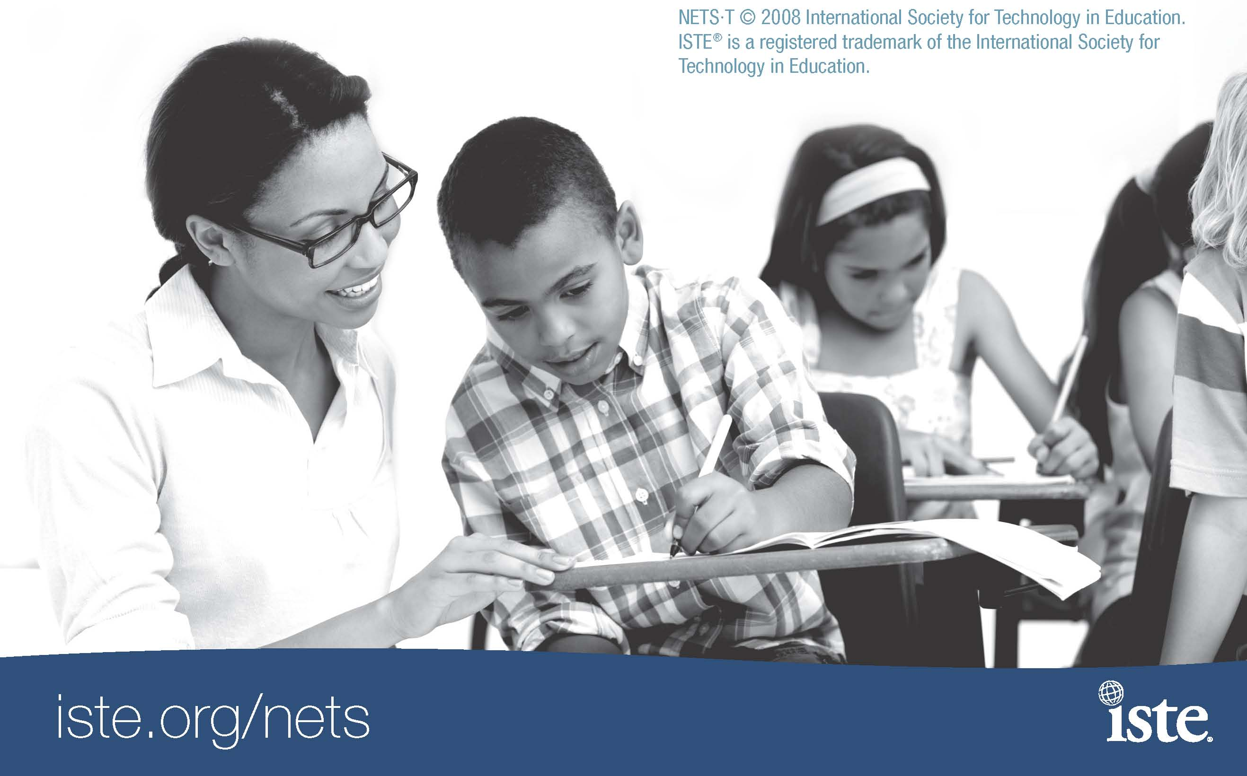
Portfolio Work Sheet [Sample]
For each of the 21things, please utilize the following format to provide a screen shot and reflection. Submit the entire portfolio to your instructor by the deadline. Include additional pages where appropriate to attach additional information.
Participant Name: District:
Thing: Time Logged:

REFLECTIONS & SCREEN SHOTS -- Part A – Completing the “Hands-On Activities” for each “Thing”

For each “thing”, complete the hands-on activity found at the web site. Using the tools and strategies for best practice instruction, you will be asked to reflect on classroom applications.
Document your completion by inserting screen shots and reflections into the portfolio template found on your agency page (e.g. 21things1.weebly.com)or within your online course environment (e.g. Moodle or BlackBoard).
21things1.weebly.com

CAPSTONE ACTIVITY -- Part B and C
Part B. Review the “things” that you learned during this segment. Describe how each new “Thing”, or technology tools supports the effective teaching and learning strategies found in Classroom Instruction That Works (Marzano, et. al). Connect technology to best practice and explain how the tools found in this section can be used to support each strategy , thus making a difference in the learning experience for your students.
Part C. Create your own project-based student activity lesson you could implement in your classroom that meets: 1) Common Core or Michigan curriculum standard; and 2) Educational Technology standard (NETS-S and/or METS). (Samples can be viewed at: http://21things4students.net/share-lessons.html). Your lesson should use one or more of the 7 things you have learned about, and utilize the format/template below.
You will complete three Capstone Assignments – at the end of things 1-7, things 8-14, and things 15-21

All students will submit a draft and a final of each Portfolio with Capstone (1-7, 8-14, 15-21). Concerns/comments must be addressed and resubmitted as a “final”.

Proficiency Score: | Score | Score | Score | Score | Score
Lickert Scale | 1 | 2 | 3 | 4 | 5
NETS-T Performance Proficiency | ------ | Beginning | Developing | Proficient | Transformative

21things4teachers
The Lesson Plan template can be found at your agency site or within your online course environment. Please utilize this template to create your lessons as part of Capstone 1 (Things 1-7), 2 (things 8-14), and 3 (Things 15-21).
Lesson Plan

TOOLS: (21things4teachers tool(s) used in this lesson)

TITLE:

GRADE LEVEL:

LEARNING OBJECTIVES: (list or describe what you want the students to know or be able to do…)

TIME FRAME: (number of sessions, length of periods):
TEACHER RESOURCES: (materials, equipment, technology):

STUDENT RESOURCES: (materials, equipment, technology):

TEACHER PREPARATION: (downloads, links, copies, filtering issues):

STUDENT DIRECTIONS/STEPS: (procedures and activities):

Classroom Instruction that Works Connections (Check all that apply)
- Setting Objectives and Providing Feedback
- Reinforcing Effort and Providing Recognition
- Cooperative Learning
- Cues, Questions, and Advance Organizers
- Non-linguistic representations
- Summarizing and Note-taking
- Assigning Homework and Practice
- Identifying Similarities and Differences
- Generating and Testing Hypothesis

(For further information on the CITW 9, visit http://www.21things4teachers.net).

ASSESSMENT/RUBRIC: (share your rubric and assessment/evaluation criteria)

STANDARDS: Curriculum Standards and Technology Integration:
National Educational Technology Standards
Core Content National Standards or Michigan State Standards as applicable:
CREDITS: (Creator Name / School District / Intended Audience (grade/class))

21 Things for 21st Century Educators by CCRESA, IISD, MISD, SRESD is licensed under a Creative Commons Attribution-Noncommercial-No Derivative Works 3.0 United States License. Based on a work at 21things.weebly.com. Permissions beyond the scope of this license may be available at http://21things4teachers.net/ Document updated August 15, 2012.
Credit Offerings and Evaluation
Participants have the option of taking this class for 3 credits or 4 credits. All participants are required to attend the first 2 hour session of the semester and then be able to choose the other sessions they attend (based on the content presented) for the appropriate number of hours needed for the credit requirements. Evaluation will be based on meeting the completion of Portfolio, reflection, work log, and virtual session items as determined by the credit option selected.

Participants that choose the 3 credit options will have a minimum of 47 contact hours. These would be obtained by:
- Attending Session 1 (2 hours)
- Attending additional Virtual sessions (Sessions 2,3,4,5,6) totaling 5 hours
- Attend/complete online sessions (Things 1-16) totaling 40 hours
- Complete Digital Portfolio with Reflection Journal and Work Log (Things 1-16)

Participants that choose the 4 credit options will have a minimum of 62 contact hours. These would be obtained by:
- Attending Session 1 (2 hours)
- Attending additional Virtual sessions (Sessions 2,3,4,5,6,7,8) totaling 7 hours
- Attend/complete online sessions (Things 1-21) totaling 53 hours
- Complete Digital Portfolio with Reflection Journal and Work Log (Things 1-21)

Evaluation Criteria ( 3, 4 credit option)
The course grade will be a letter grade, minimum for an A is 90%, a B is 80%, a C is 70%, a D is 60%, and below is failing.
- 20% Attendance/Work Log
  - Session 1 – 2 hours face to face session
  - Sessions 2-8 – Virtual online sessions, participation, chat, discussion, participation
- 40% Portfolio Drafts - digital portfolio of hands-on activities, includes screen shots and reflections with lesson plans in draft form
- 40% Portfolio Final – Error free digital portfolio with edits/changes and updated lesson plans for repository

All evaluations will be based on the NETS•T National Educational Technology Standards for Teachers
NETS•T I Technology Operations and Concepts
NETS•T II Planning and Designing Learning Environments and Experiences
NETS•T III Teaching, Learning, and the Curriculum
NETS•T IV Assessment and Evaluation
NETS•T V Productivity and Professional Practice
NETS•T VI Social, Ethical, Legal, and Human Issues
Credits | Minimum Requirements  Portfolio and Reflections items | Minimum Requirements Work Log items | Recommended Minimum Proficiency for each Thing
3 credits | Things 1-16 | Things 1-16 | Proficient
4 credits | Things 1-21 | Things 1-21 | Proficient

In determining proficiency for each Thing, the following equivalents are presented to determine performance.
Item/Source | Score | Score | Score | Score | Score
Lickert Scale | 1 | 2 | 3 | 4 | 5
Grading Scale Percent | 0-59% | 60-69% | 70-79% | 80-89% | 90-100%
Grading Scale Grade | E | D | C | B | A
Rubric Description | Not familiar with tool, No knowledge | Beginning Awareness, Know what it is/haven’t used it, Limited knowledge | Awareness, Somewhat experienced and worked with it a few times, Somewhat knowledgeable | Active Awareness, Experienced and proficient user, Very knowledgeable | Flexible Awareness, the integration of multiple tools at a high level of functionality
NETS-T Performance Proficiency | ------ | Beginning | Developing | Proficient | Transformative

Evaluation Criteria: (based on credits earned)
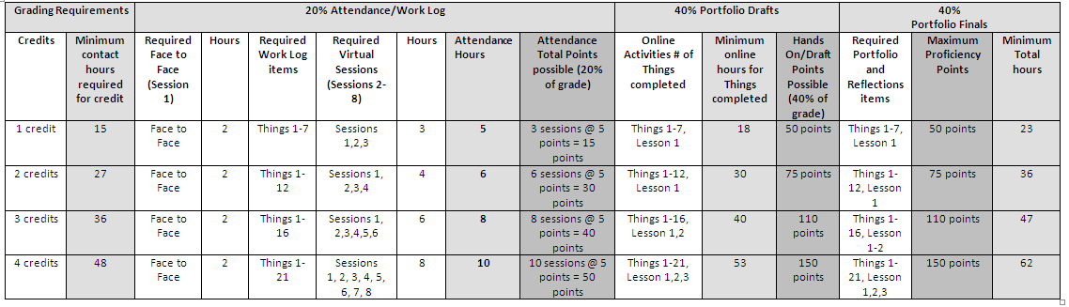
Note: Each “thing” is worth 5 points, and each Lesson is worth 15 points. For Example, Things 1-7 @ 5 points = 35 points + Lesson 15 points = 50 points total. To calculate student grade:

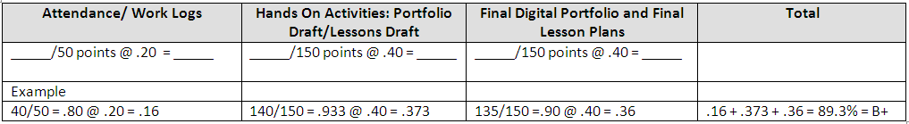
21things Submission Instructions
REQUIRED SUBMISSIONS
IMPORTANT: For participants to earn SCHECHs, they must complete and log the minimum required hours for the entire program as required by the Michigan Department of Education (MDE). This means attending all sessions according to the approved schedule including arriving on time and remaining for the duration of each session. The MDE and MISD review all programs and monitor attendance. Failure to comply with program requirements, including attendance and completion of this portfolio will result in disallowance of SCECH credit. In order to be granted credit, required elements:
- Submit completed portfolio online to your instructor using your ISD’s course Moodle website found at http://moodle.wmisd.org final paperwork by due date. ONLY THE PORTFOLIO MAY BE SUBMITTED DIGITALLY.
- Complete and Sign Work Log/Time Log with actual logged hours to meet or exceed minimum required hours. This log includes mandatory attendance at the Face to Face session, and active participation in the online sessions to complete all 21things.
- Indicate Preference: I am taking this course for (select one):
Professional Development Hours  Submit time log and portfolio release to.  Karen Emond  REMC 2 South  9905 East 13th Street  Cadillac, MI 49601 | SBCEUs  Complete the SCECH application form, distributed at the Face-to-Face session. Submit time log, portfolio release and SCECH application form to:  Karen Emond  REMC 2 South  9905 East 13th Street  Cadillac, MI 49601
Graduate Credits CMU
Submit your course registration materials and payment using form distributed at Face-to-Face session. Submit time log/portfolio release to REMC 2 South.. CMU Questions, contact Katie Warren at warre1kd@cmich.edu (989 774 4477)

- Upon completion of the course, submit log sheets, SBCEU application by April 24, 2013 to:
Karen Emond
REMC 2 South
9905 East 13th Street
Cadillac, MI 49601

ALL DOCUMENTS MUST BE RECEIVED by April 24, 2013. Remember to make a copy of your documents for your records. Original forms with signatures must be mailed in. Only the portfolio may be submitted digitally.

Name (please print)
Address/City/Zip
School/District /
Signature PIC # _________________________________
I understand that any deviation from this criterion will result in my loss of SB-CEU credit.
SB-CEU Program #: Will be given out upon completion Program Title: 21things for the 21st Century Educator
Beginning Date: January 9, 2013 Ending Date: April 24, 2013

Work Log
Work Log/Time Log [Launch, Hands-On Activities and Adobe Connect Sessions]
NOTE: THIS IS VERIFICATION OF YOUR ATTENDANCE
Course End Date: April 24, 2013
Use these pages to keep track of hours per session. You must meet the minimum contact hours and submit this log at the end of the course as verification of your attendance. Hands On Activities found at: http://www.21things4teachers.net or within your Course Management System ([Moodle, Blackboard, etc.])
Online Sessions | Activities |  | Time Guide  [Minimum] | Logged Hours
January 16 2013  4:30 – 6:30 pm  TENTATIVE BY LOCATION  *On site @ Agency begins | *21THINGS LAUNCH*  Thing 0 – An Introduction to the Course  (REQUIRED: Face to Face meeting) |  | 2 hours
January 23, 2013  4:00-5:00 pm | Adobe Connect (Online) Session 1  - About Basics  - Face of the Classroom  - Collaboration Tools |  | 1 hour
About Basics  MS Office keyboard shortcuts; Delicious/Diigo | *Review of “Thing”  *Review of Web Tools that support “Thing”  *View video or tutorial  *Application of NETs for Teachers  using Web Tool(s)  *Complete Assignment and Portfolio reflection |  | 2 hours
Face of Your Classroom  CMS: BlackBoard, Moodle, EdModo; Personalized web pages: Weebly; Blogs: EduBlogs; Wikis or Online Infrastructure: Wikispaces, PBWorks; or Local district resources | *Review of “Thing”  *Review of Web Tools that support “Thing”  *View video or tutorial  *Application of NETs for Teachers  using Web Tool(s)  *Complete Assignment & Portfolio reflection |  | 3 hours
Collaboration Tools  Google Docs, Lino, Doodle | *Review of “Thing”  *Review of Web Tools that support “Thing”  *View video or tutorial  *Application of NETs for Teachers  using Web Tool(s)  *Complete Assignment & Portfolio reflection |  | 3 hours
January 30, 2013  4:00-5:00 pm | Adobe Connect (Online) Session 2  - Communication Tools  - Content Area Tools  - Differentiated Instruction -Diverse Learning |  | 1 hour
Communication Tools  BackChannel chat, Skype | *Review of “Thing”  *Review of Web Tools that support “Thing”  *View video or tutorial  *Application of NETs for Teachers  using Web Tool(s)  *Complete Assignment & Portfolio reflection |  | 3 hours
Content Area Tools  Thinkfinity, M.O.R.E., Testmoz, Socrative, PollEverywhere | *Review of “Thing”  *Review of Web Tools that support “Thing”  *View video or tutorial  *Application of NETs for Teachers  using Web Tool(s)  *Complete Assignment & Portfolio reflection |  | 3 hours
Differentiated Instruction & Diverse Learning  CAST, Learnport, Nettrekker Vozme | *Review of “Thing”  *Review of Web Tools that support “Thing”  *View video or tutorial  *Application of NETs for Teachers  using Web Tool(s)  *Complete Assignment & Portfolio reflection |  | 3 hours
February 6, 2013  4:00-5:00 pm | Adobe Connect (Online) Session 3  - Digital Citizenship  - Visual Learning  - Copyright & Creative Commons |  | 1 hour
Digital Citizenship  Digital Citizenship, Acceptable Use, Critical Evaluation, Bogus/Hoax sites, CyberSafety | *Review of “Thing”  *Review of Web Tools that support “Thing”  *View video or tutorial  *Application of NETs for Teachers  using Web Tool(s)  *Complete Assignment & Portfolio reflection |  | 3 hours
Visual Learning  Graphic organizers: Bubbl.us, Gliffy, Wordle, Tagxedo | *Review of “Thing”  *Review of Web Tools that support “Thing”  *View video or tutorial  *Application of NETs for Teachers  using Web Tool(s)  *Complete Assignment & Portfolio reflection |  | 3 hours
Copyright & Creative Commons  Copyright, Fair Use, Creative Commons, Teach Act, Public Domain | *Review of “Thing”  *Review of Web Tools that support “Thing”  *View video or tutorial  *Application of NETs for Teachers  using Web Tool(s)  *Complete Assignment & Portfolio reflection |  | 2 hours
February 13, 2013  4:00-5:00 pm | Adobe Connect (Online) Session 4  - Digital Images  - Presentation Tools  - Evaluation & Assessment |  | 1 hour
Digital Images  FotoFlexer, PicasaWeb, Avatars/Voki | *Review of “Thing”  *Review of Web Tools that support “Thing”  *View video or tutorial  *Application of NETs for Teachers  using Web Tool(s)  *Complete Assignment & Portfolio reflection |  | 2 hours
Presentation Tools  Prezi, Glogster, ZoomIt | *Review of “Thing”  *Review of Web Tools that support “Thing”  *View video or tutorial  *Application of NETs for Teachers  using Web Tool(s)  *Complete Assignment &Portfolio reflection |  | 3 hours
Evaluation & Assessment Tools  Rubistar, Google Forms, data warehousing and student information system tools, FERPA/HIPAA | *Review of “Thing”  *Review of Web Tools that support “Thing”  *View video or tutorial  *Application of NETs for Teachers  using Web Tool(s)  *Complete Assignment & Portfolio reflection |  | 3 hours
February 20, 2012
Capstone 1, Things 1-7
Technology integration, Curriculum Connections, Lesson Plan
Due Date
February 27, 2013  4:00-5:00 pm | Adobe Connect (Online) Session 5  - Online Interactive Learning Tools  - Productivity Tools  - Staying Informed |  | 1 hour
Online Interactive Learning Tools  Google Earth, Quizlet, Vocabulary SpellingCity | *Review of “Thing”  *Review of Web Tools that support “Thing”  *View video or tutorial  *Application of NETs for Teachers  using Web Tool(s)  *Complete Assignment & Portfolio reflection |  | 3 hours
Productivity Tools  ZamZar, Google Calendar, Drop Box, Evernote | *Review of “Thing”  *Review of Web Tools that support “Thing”  *View video or tutorial  *Application of NETs for Teachers  using Web Tool(s)  *Complete Assignment & Portfolio reflection |  | 2 hours
Staying Informed  RSS, Horizon Report, Ted Talks, Netvibes, Portable Mobile | *Review of “Thing”  *Review of Web Tools that support “Thing”  *View video or tutorial  *Application of NETs for Teachers  using Web Tool(s)  *Complete Assignment & Portfolio reflection |  | 2 hours
March 6, 2013  4:00-5:00 pm | Adobe Connect (Online) Session 6  - Online Video & Audio Resources  - Professional Learning Networks |  | 1 hour
Online Video & Audio Resources  Online Video:  United Streaming, School Tube, Teacher Tube, Khan Academy  Audio:  iTune, iTunesU, Podcasting | *Review of “Thing”  *Review of Web Tools that support “Thing”  *View video or tutorial  *Application of NETs for Teachers  using Web Tool(s)  *Complete Assignment & Portfolio reflection |  | 3 hours
Professional Learning Networks  Professional organizations, Twitter, MACUL Space, Michigan LearnPort, LinkedIn | *Review of “Thing”  *Review of Web Tools that support “Thing”  *View video or tutorial  *Application of NETs for Teachers  using Web Tool(s)  *Complete Assignment &Portfolio reflection |  | 2 hours
March 13, 2013  4:00-5:00 pm | Adobe Connect (Online) Session 7  - Research & Reference Tools  - Virtual Classroom |  | 1 hour
Research & Reference Tools  MEL, RefDesk, Google Scholar, Citation tools | *Review of “Thing”  *Review of Web Tools that support “Thing”  *View video or tutorial  *Application of NETs for Teachers  using Web Tool(s)  *Complete Assignment & Portfolio reflection |  | 3 hours
Virtual Classroom  Online Learning guidelines, Video Conferencing  Navigating The Land of Online Learning, TWICE/CAPSpace, Adobe ConnectNow | *Review of “Thing”  *Review of Web Tools that support “Thing”  *View video or tutorial  *Application of NETs for Teachers  using Web Tool(s)  *Complete Assignment &Portfolio reflection |  | 2 hours
March 20, 2013
Capstone 2, Things 8-14
Technology integration, Curriculum Connections, Lesson Plan
Due Date
March 20, 2013  4:00-5:00 pm |  | Adobe Connect (Online) Session 8  - Digital Story Telling  - Flip Your Classroom (Screen-casting) | 1 hour
Digital Story Telling  Photo Story 3, iMovie |  | *Review of “Thing”  *Review of Web Tools that support “Thing”  *View video or tutorial  *Application of NETs for Teachers  using Web Tool(s)  *Complete Assignment & Portfolio reflection | 3 hours
Flipping Your Classroom:  Screen-casting  Jing, Screencast-o-matic; posting and sharing online (iTunes), WeVideo |  | *Review of “Thing”  *Review of Web Tools that support “Thing”  *View video or tutorial  *Application of NETs for Teachers  using Web Tool(s)  *Complete Assignment & Portfolio reflection | 3 hours
April 24, 2013
Capstone3, Things 15-21
Technology integration, Curriculum Connections, Lesson Plan
Due Date

Complete Digital Portfolio and Signed Time Log Due Date

Face-to-Face, Virtual & Online Instruction Combined Total Hours |  |  | 66

This is to certify that the 21things Portfolio and the logged hours are an accurate reflection of my time on

the project.

Signature: _____________________________________
Date:_________________________________________

Project Partners for 21things for the 21st Century Educator
21 Things for the 21st Century Educator
Use of Participant’s Work/Portfolio

Dear Participant:
As part of “21 Things for the 21st Century Educator” we would like permission to publish portions of your portfolio online as an example of excellent work. Note that these pages include your name and district. We would also like permission to circulate your completed portfolio during face-to-face trainings to incoming participants. Signing this form officially documents that you will allow the use of your portfolio for instructional and demonstration purposes within the context of the "21Things for the 21st Century Educator” course. There is no monetary compensation for the use of your work.
I release the Clinton RESA, Macomb ISD, Shiawassee RESD, and/or Ingham ISD and their Board of Education, the individual members, agents and employees and representatives from financial consideration, pertaining to these projects or images. I promise not to initiate a lawsuit in any court of the United States to compel, enjoin or enforce legal claims which I have waived by execution of this Agreement.
This release includes, but is not limited to, my waiver of all proceeds or advantages derived from the reproduction or publication of my work.

Print Name District/School

Dated:
Signature

Please sign and submit with portfolio by due date.

